|  |
| --- |
| **Mr.Rakesh Kumar**  **M.Sc. (Chemistry) B.Ed.**  CTET, PSTET, HPTET qualified  thakurkumar82@gmail.com |
| **Class:-XII (Sci.) Name of Student……………………**  **Subject:- Chemistry**  **10 year QuStions**  **Chapter-6**  **General principles and processes of isolation of elements** |

1. Write the role of the following ;
2. NaAlF4 in the extraction of Aluminium.
3. CO in the refining of nickel (Ni)
4. Write the chemical equations involved in the leaching of bauxite ore to prepare pure alumina.
5. Write the chemical reactions which take place in the following operations:

(i) Electrolytic reduction of A*l*2O3. (ii) Isolation of zinc from zinc blend.

(iii) Mond’s process for refining nickel.

1. 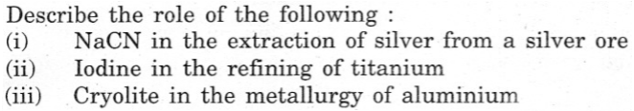
2. Describe the principle involved in each of the following processes of metallurgy; (i) Froth floatation process (ii) Electrolytic refining of metals
3. Zone refining of metals
4. 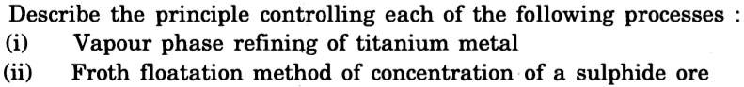
5. Which methods are generally employed for purifying the following metals; (i) Nickel (ii) germanium, also mention the principle behind each of them.
6. Describe the role of the following: (i) SiO2 in the extraction of copper from copper matte (ii) NaCN in froth floatation process.